* **Activity 6:**

No Rows Returned by the Inner Query

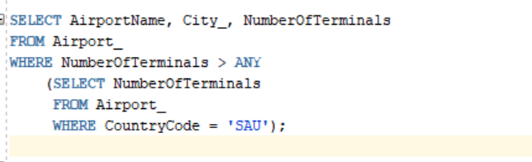

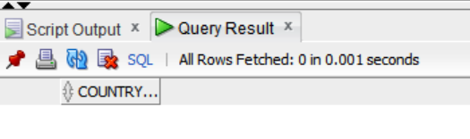OUTPUT: